INSPIRER TEENS SYLLABUS

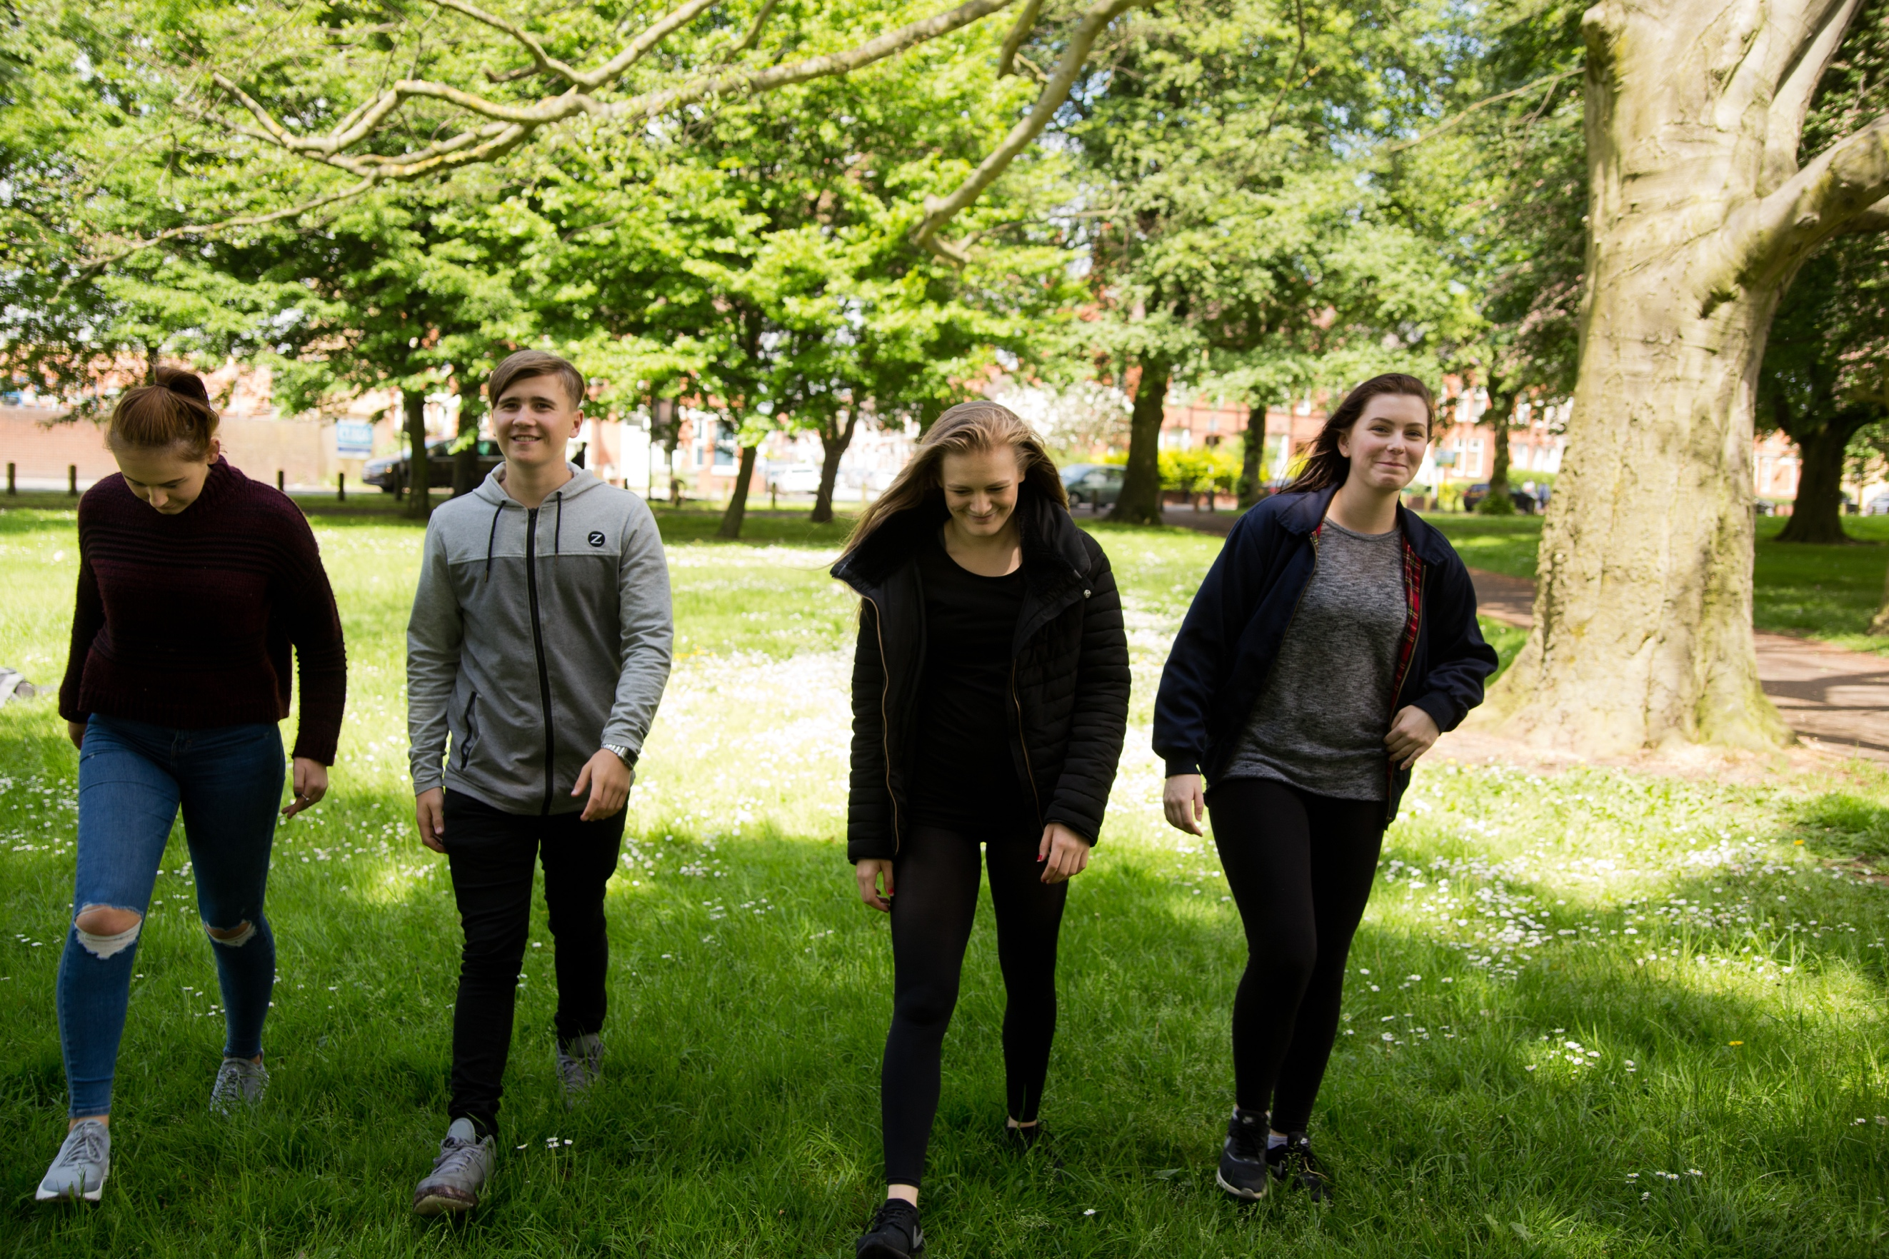

The Inspirer Syllabus

Course breakdown

The course has been broken down into 4 24 hour modules to:

1: Enable prospective students to learn at their own pace
2: To allow students to digest and absorb the material in their own bodies and daily life which is essential
3: Give students the time they really need to understand the complexities of teenage development which takes time and practice

Unlike any other course out their Inspirer encompasses a range of disciplines including yoga, Pilates, energetic anatomy, partner work, natural movement and personal development. This is to equip prospective teachers with a real wealth of skills that will enable them to:

1: Understand the challenges that young people and those who work with them face
2: Understand how these challenges manifest on both a physical, physiological, mental and emotional level
3: To understand how to identify physical, physiological, mental and emotional challenges in young people
4: To create lesson plans that are relevant, fun and supportive

Who teaches what?

At least 70% of the course is taught by a YAP principal teacher.

Elena Voyce, the founder of Inspirer teaches the whole of the second module of the course. This is her specialism and no one can teach this part of the course better than her.

Amy Zara and Rebecca Hannah teach the other 3 modules, splitting up their strengths to deliver you the strongest teaching they can. They have had the most experience teaching young people in school settings and therefore, are the best people to deliver these aspects of the course.

Jesse Saunders and Ryan Cardlon-Miah bestowed the partner work and natural movement to us and to honour their amazing contribution to our course one of them will come in to teach 2 hours to you. If Jesse teaches it will be the partner work, if Ryan teaches it will be the natural movement. Rebecca and Amy will then teach you how to make these disciplines relevant to teenagers.

How the course works

Inspirer is split into the following 4 modules each of which are run over 3 days and include 24 hours contact time with our course tutors making the total amount of contact hours 96.

1: Inspirer Foundation: An introduction to working with teens

2: Inspirer Energetic Anatomy: The connection to the Meridians

3: Inspirer: Partner Work and Natural Movement

4: Inspirer: Bespoken classes for physical, physiological, mental and emotional needs

Homework

As well as the contact hours on these four modules you will be expected to practice and absorb what you have learnt on the modules as part of your homework. We would expect this to total about 40 hours of non-contact time.

- Practice exercises you have learnt from each module.
- Complete the personal development exercises for teachers.
- Create your own lesson plans.

Who is the course for? (Course Requirements)

To become a qualified Inspirer Teacher, you must have at least one of the following:

- A 200-hour yoga teacher training certificate with a recognised yoga school
- A certificate in Pilates or personal training
- A degree in Sports Science or Teaching physical education

Course Length: 96 contact hours

Inspirer Foundation: 3 x days, 24 hours contact time

Outcomes/Objectives

- To understand what the Inspirer Method is and how to use it in your home/work/practice – A look at the inner and outer circle model and how to use it
- You will learn mental/emotional and physical (Anatomical awareness) of the growth and development of teens
- Gain an understanding of Inspirers unique approach towards sequencing movement and how to effectively use it. This will include an exploration of the course director's unique method RASS which is used by teachers across the world
- Learn the tools and techniques for common teenage ailments including headaches, period pain, text neck, digestive problems and unstable core
- Learn the Inspirer approach towards creating lesson plans
- Gain an understanding of behavioural management tools and techniques to use with teens
- Learn how to use Pranayama safely and effectively with teens
- Learn how to incorporate yoga philosophy and meditation into working with teens through personal development exercises and techniques
- Gain the tools to approach schools, safeguarding and policies and procedures involved in working with teens

Inspirer Energetic Anatomy: 3 x days, 24 hours contact time

Outcomes/Objectives

Learn a non-invasive, non-judging, self-empowering and self-educational holistic method to equip you with techniques and knowledge to:

- Identify and address the 10 anatomical variables which you will need to understand and master to safely teach teens as they grow and develop.
- Learn how these 10 anatomical variables are affected by their closest surroundings, which includes family, schools, pressure etc. in ways that connect to times of the year.
- See muscles and their ability to move, shorten and stretch. Not under the strictly anatomical lens but under the emotional and physiological lens.
- Understand the natural year clock on the body and mind and why the way we teach the sequences we teach should change based on the natural clock of the year not based on trend.

Inspirer Partner Work and Natural Movement 3 x days, 24 hours contact time

Outcomes/Objectives

Learn fun and inspiring ways to encourage good teamwork, stamina and natural healthy movement of the body to connect the body to what you do in your own time i.e. football, gymnastics, dance, rugby, tennis etc.

- Partner and group exercises, games for team building, trust and communication
- Partner work for strength, alignment and flexibility
- Learning the key animal movements
- Learning the benefits of animal movement and how they can be incorporated into your teaching/practice
- The benefits of using partner work and natural movement with teens
- How to adapt partner work and natural movement for teens so it is safe and effective
- How to integrate partner work and natural movement into your Inspirer Lesson Plans

Inspirer: Be spoking 3 x days, 24 hours contact time

Outcomes/Objectives

- An understanding of common physical, mental and emotional disorders
- An understanding of how to recognise the symptoms of mental and emotional health problems
- An understanding of how physical, mental and emotional health conditions affect both the body, mind and behaviour
- How to adapt movement safely for common physical, mental and emotional implications
- How to manage challenging behaviour through personal development
- A deeper look of how Inspirer can be integrated into schools with a further focus on Key Stages, the Curriculum, Initial Assessment, Learning Outcomes, Evaluation
- A look at how Inspirer can be Integrated into the Community
- Assessment and graduation

Qualification

Our teacher training course has met the stringent requirements set by Yoga Alliance Professionals. Our graduates are trained to the highest standard and are eligible to register with Yoga Alliance Professionals as an Affiliate Member.

